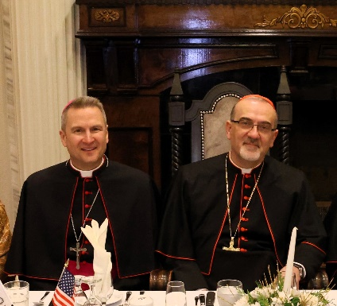
WHAT DO WE DO WHEN WE DO NOT KNOW
WHAT TO DO?
Bishop Hicks with Cardinal
Pierbattista Pizzaballa
Throughout the journey of our lives, we all experience moments of uncertainty, ambiguity, or indecision. We can feel small, inadequate, and almost paralyzed as we face looming problems ranging from our own personal issues to worldwide crises.
Grounded in faith, Saint Francis of Assisi wisely taught that when we do not know what to do, we should “pray, obey, and love.” Our Catholic tradition reflects his wise counsel.
PRAY In the good times and bad, we turn to God in prayer. Through prayer, we realize that we are not the center of the universe, as we raise our hearts and minds to God. As Jesus taught, “For human beings this is impossible, but for God all things are possible” (Matthew 19:26).
OBEY While prayer is the proper first step, it should not end there. We also need to be obedient to God, always discerning: What is the best response according to God’s command, law, and divine will?
LOVE However we respond to problems, our actions should always reflect Christ’s love, specifically following the greatest commandment: “You shall love the Lord, your God, with all your heart, with all your soul, and with all your mind… and you shall love your neighbor as yourself” (Matthew 22: 37–39).
Since October 2023, the conflicts in the Holy Land have escalated into a horrible war. Most of us follow the news with broken hearts and feel helpless.
Recently, I attended a dinner in Chicagoland (photo above) at which His Beatitude Cardinal Pierbattista Pizzaballa, spoke about the realities in the Holy Land.
Born in Italy in 1965, Cardinal Pizzaballa entered the Franciscan Order. He serves as the Latin Patriarch and Archbishop of Jerusalem. On January 27, 2024, we gathered at a dinner hosted by the Arab American Catholic Community (AACC), which exists to unite and support Catholic Arabs within the United States. In attendance were also many Knights and Dames from the Equestrian Order of the Holy Sepulchre. Its mission includes supporting and promoting the Holy Land and protecting the Christian presence there. I am humbled to

belong to this ancient and noble order and am proud to witness the local members’ dedication and commitment to this mission.
Known for his constant efforts to promote solidarity, cultural and historical preservation, interreligious dialogue, and embrace and advocate for peace, justice, and reconciliation, Cardinal Pizzaballa’s 45-minute presentation literally quieted the entire banquet room, as even the waitstaff stopped to listen to his every word. He called for a ceasefire and spoke of the Catholic Church’s boundless efforts to provide food, shelter, housing, healthcare, and spiritual care for those affected by the war.
He also prophetically commented that instead of striving for peace in the current war, both sides unfortunately are fighting only for victory — a victory that clearly delineates a winner and a loser. “Peace is not victory,” said Cardinal Pizzaballa. “It is the willingness on both sides to give something up for the greater good.”
He spent a lot of time laying the foundation for the need for true peace, a peace which is reflected only in Jesus. He reminded us that peace is not the absence of conflict. Instead, it includes the presence of justice, reconciliation, discernment of God’s will, and the desire for the common good.
This Lent, as we prepare ourselves to enter this season of prayer, fasting, and almsgiving, you might consider donating to a reputable organization or charity that aids and services to those in need in the Holy Land; some suggestions are included at the bottom of this article. Also, on Good Friday, throughout the Diocese of Joliet, a collection will be taken up to support the work of the Franciscans working in the Holy Land.
The Holy Land holds a powerful place in our hearts and in salvation history. It is where Jesus was born, grew up, taught, prayed, performed miracles, suffered, died, and was resurrected. In solidarity, let us join Cardinal Pizzaballa’s call for an end to the violence and for a just and lasting peace in the Holy Land as we turn to God with prayer, obedience, and love.
Jesus, Prince of Peace, pray for us.
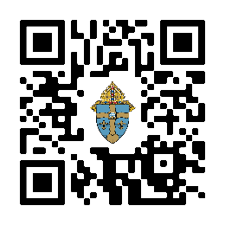
Holy Land Humanitarian Agencies
• Equestrian Order of the Holy Sepulcher Humanitarian Fund
• Catholic Relief Services (U.S. arm of Caritas International)
• Franciscan Foundation for the Holy Land Humanitarian Programs
Scan the QR code for links or visit diojoliet.org

• Catholic Near East Welfare Association Emergency Holy Land Fund

