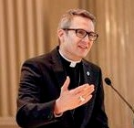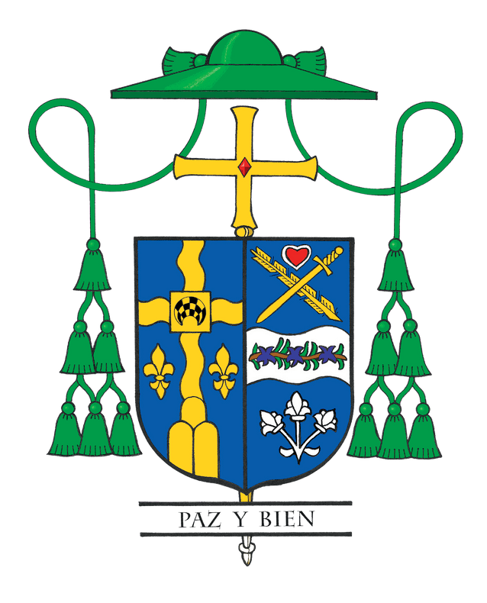Bishop Hicks' Column

November 2022: Our Baptismal Duty

Recently, many of us tuned in to watch the events surrounding the passing of Queen Elizabeth II, the longest reigning British monarch. In the United States, the existence of a royal family may be somewhat of a foreign concept in our political system that prefers democratically elected officials. Yet, with some curiosity, many of us cast our gaze across the pond to capture a glimpse of the new King Charles III receiving the royal scepter.

In the Catholic Church, we tap into “royal language” with titles like “Queen of Heaven” and the “Prince of Peace.” During this month, we will come to the end of our liturgical year when the universal Church boldly proclaims Christ as King of the Universe on November 20.

Pope Pius XI instituted the celebration of “Christ the King” in 1925 with his encyclical Quas primas (“In the first”) to respond to growing secularism and atheism in the world. From the U.S. Conference of Catholic Bishops: “This solemnity reminds us that while governments come and go, Christ reigns as King forever. During the early twentieth century, in Mexico, Russia and some parts of Europe, militantly secularistic regimes threatened not just the Catholic Church and its faithful, but civilization itself.”

Almost 100 years after the solemnity’s inception, there is still a need to promote the message of this feast day. We do not have to look far to see blatant attacks on religious liberty and increasing secularism. It is in this context that atheists are proactively trying to convert vulnerable minds to not believing in God. Still, there are others who plant a deceptive message by saying, “If you insist on believing in God, at least do so by being only spiritual and not religious within the Church.”

While we embrace Christ as our king, we also need to remind ourselves that he is a very different kind of king. Instead of donning a crown of gold, Jesus wears a crown of thorns, and instead of ruling with arrogance or revenge, he utters decrees of mercy and
forgiveness: “Father, forgive them, for they do not know what they are doing” (Luke 23:34). Jesus rules by being a good shepherd who rejects loftiness and domination. Instead, he serves, as opposed to seeking to be served. He calls all those who follow him to join his ministry of service, humility, forgiveness and charity.

During the past few years, there has been a popular streaming series named “The Crown.” In the first season, there is a poignant scene in which King George VI reminds his son-in-law, Philip, of his duty, especially toward the new queen, Elizabeth II. “You understand, the titles, the dukedom. They’re not the job. She is the job! She is the essence of your duty. Loving her. Protecting her.”

For those of us who have been called to minister in the Church, I think this quote is quite appropriate. It applies not exclusively to bishops, clergy and religious, but to every Catholic who is baptized and is a missionary disciple of Jesus: ”The Church is our duty. Loving her. Protecting her.”

In the rite of baptism for children, the parents listen to the following words before the water is poured: “You have asked to have your child baptized. In doing so, you are accepting the responsibility of training him or her in the practice of the faith. It will be your duty to bring him or her up to keep God’s commandments as Christ taught us, by loving God and our neighbor.” When parents are asked, “Do you clearly understand what you are undertaking?” the affirmative answer they give at that moment is hopefully repeated daily and throughout the course of their lives.

To accomplish this, I continue to invite us to follow my vision for this diocese of Catechesis, Evangelization and Faith into Action. For if we truly know Jesus, love Jesus and serve others like he taught us, then we are doing our baptismal duty. As we strive to keep God at the center of our lives, the Church and the universe, may Christ the King live and reign today and always.

