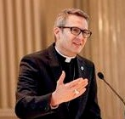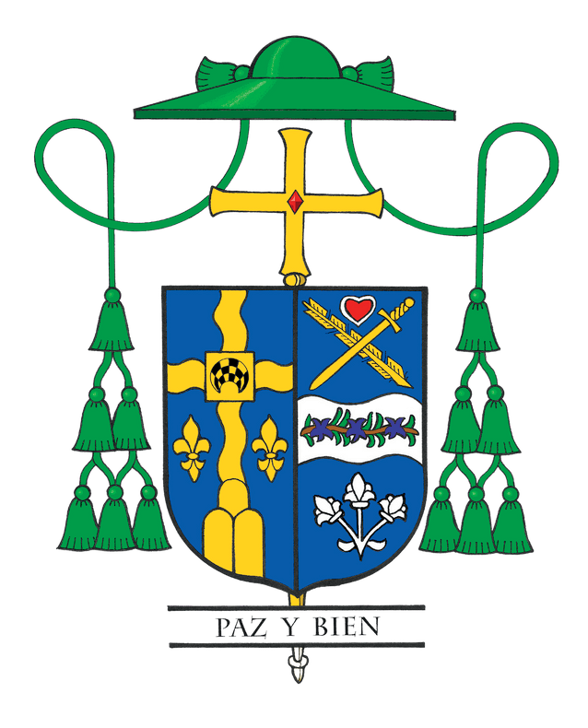Bishop Hicks' Column

May 2023:
Calling Joyful Shepherds

This year we will ordain five new priests for the Diocese of Joliet. While this quantity is outstanding, so is their quality. These five men are young, intelligent, faith filled, pastoral and enthusiastic, and they all strive for holiness. They easily could have followed one of many good and exciting career paths offered by the world. Counterculturally, they heard the call of the Lord and responded by choosing to follow the call to the vocation of ordained priesthood.

We are blessed in the Diocese of Joliet to have 23 seminarians studying for the priesthood. However, we cannot rest on our laurels. Encouraging young men to consider the priesthood is the responsibility of the entire people of God.

The question becomes, “How do we invite and encourage others to discern a life to the priesthood or religious life?” Most of us, I hope, feel comfortable praying for vocations and donating to our Seminarian Endowment Fund to help cover the costs of seminarian formation. However, when it comes to proactively inviting others to it, we can become tongue-tied and need help as to what we should say and do.

For that reason, I just recently sent an inspiring little book to all the priests in the Diocese of Joliet called, “Five Conversations about the Priesthood,” by Father Michael Pratt. Studies show that the local priest is one of the most influential factors for their parishioners discerning a vocation to the priesthood or religious life.
This book provides a simple and solid roadmap to intentionally encourage others to discern a priestly vocation.

Father Pratt’s book gives five practical ways to talk about the following:

1. Priestly identity.
2. The Eucharist in the priest’s life.
3. The Sacrament of Penance.
4. Preaching.
5. Parish priesthood.

While this book is geared to our priests, you might also want to consider reading it. A quick internet search of the title, or a visit to https://vianneyvocations.com will provide ordering instructions.

Just about all recently ordained priests throughout the country commonly report one of the reasons they took the leap of faith to actively discern the priesthood and to enter the seminary is that someone specifically invited them to do so. Just one voice has the power to break through all their doubts, fears and negative messaging about becoming a priest. My hope is that before we approach eternal life, we will be able to name someone specifically that we encouraged to discern the priesthood or religious life.

This may be hard to believe, but there are many parents who explicitly discourage their sons from considering the priesthood. While some parents claim it is because they want grandchildren or because they want their son to pursue a more prestigious profession and make a lot of money, the most common factor for their lack of support is because they think their son will be unhappy as a priest. Most parents’ greatest desire is for their children to be happy. If they think that priesthood is the road to unhappiness, then they tend to actively discourage the possibility of it.

Most studies reveal that priests are happy. While there are exceptions to this rule, most of us know many happy and well-adjusted priests. I, for example, empathically declare that as I celebrate 29 years of priesthood, I am happy! I say so without being naïve or sugarcoating the challenges. The priesthood, like all vocations, comes with an experience of suffering. But these moments of the cross also lead us through and to the joy of the resurrection.

In 2010, after completing five-years of living and working in El Salvador, I spoke with Cardinal George in eager anticipation of my next assignment. I clearly remember him saying to me, “Fr. Ron, I am assigning you to Mundelein Seminary to be the Dean of Formation.” Quickly brushing off my initial shock, I responded, “Well, thank you for that assignment. You know that I am obedient and will go wherever you send me. However, after spending five years in Central America and becoming fluent in Spanish, why are not sending me to be a pastor in a large, Hispanic parish, and instead sending me to the Major Seminary?” His answer surprised me, “Fr. Ron, you are a joyful priest…and the seminarians need to see your joy.”

As we give thanks for our five new priests, please join me in expressing my gratitude to the priests in the Diocese of Joliet. With them, let us all strive to joyfully and intentionally encourage others to consider a vocation to the priesthood or religious life. To learn about priestly vocations and also for ways to encourage them, please go to our website at www.diojoliet.org/vocations or contact our Office of Vocations at 815-221-6171.

