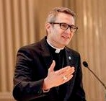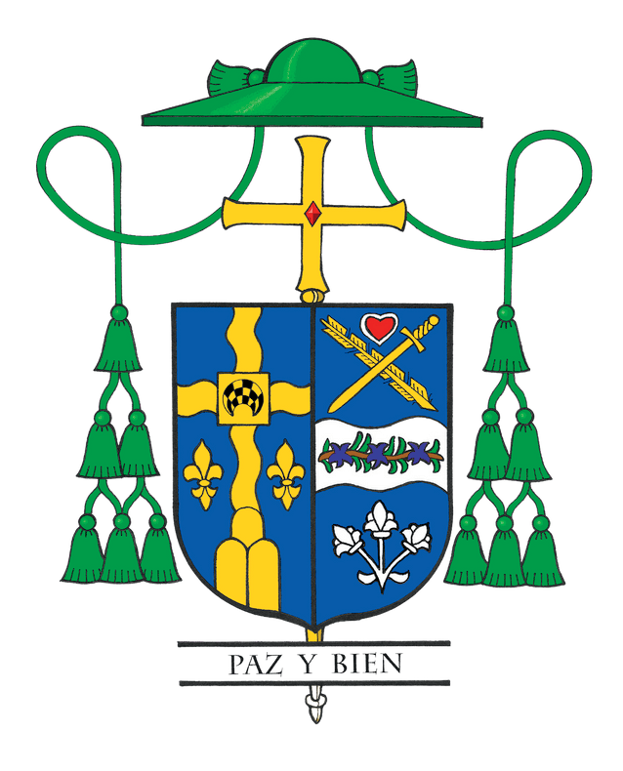Bishop Hicks' Column

June 2023:
Turning to Jesus: Healing and Hope

Saturday, May 20, 2023, the sun shone brightly over our Cathedral. That day, we ordained four men to the priesthood for the Diocese of Joliet. It was a day filled with exhilaration and hope for these new priests, as it was, too, for their families and throngs of people who had supported them along the journey to priesthood.

In my homily, I shared that priesthood is a calling from God and a true gift, not only for the new priests, but for all those they would come to serve. These priests would experience ups and downs, resurrection-joy and suffering. Through it all though, I reminded them that Jesus is always with them.

Little did I know how prophetic my message would be; and so quickly. Three days later, the Illinois Attorney General released a report based on his office’s nearly 5-year investigation of clergy sexual abuse of minors in the six Illinois dioceses. It detailed the pain, grief, betrayal, and anger inflicted on innocent individuals by clergy. Our new priests, along with the rest of us in this Catholic Church, encountered a crucifixion and the hot pain of the nails of the cross.

The Attorney General’s report highlights cases of sexual abuse in the Catholic Church, the vast majority of which, in our Diocese, occurred decades ago. The report also acknowledges the significant improvements we have made over the years to address this horrific sin.

The Diocese of Joliet implemented its first policy regarding clergy sexual abuse of minors 33 years ago. More than a decade later, in 2002, the U.S. Conference of Bishops established The Charter for the Protection of Children and Young People, a blueprint for all dioceses and eparchies for reporting sexual abuse of minors by clergy and creating safe environments for our children. As your bishop, I insure we remain true to the Charter, regularly reviewing and updating our policies to respond appropriately to victims/survivors.

I want to emphatically state this: no clergy member or layperson with a substantiated allegation of the sexual abuse of a minor is in active ministry or working or volunteering in the Diocese of Joliet.

Over the past 17 years, throughout our diocese, we have substantiated allegations of the sexual abuse of a minor/vulnerable adult against two priests. Indeed, two cases are too many. We strive for zero cases. In both situations, the priests were immediately removed from public ministry and law enforcement took over. Ultimately, both priests were incarcerated and had their canonical faculties removed. Both men are listed on our website’s public list, along with priests whose cases date from decades ago.

Reporting and removing abusive clergy from our church is
absolutely necessary and we’ve been doing it here effectively for more than 30 years. Since 2006, the diocese has published a public list of clergy with substantiated allegations of sexual abuse of a minor or vulnerable adult. The list includes names of religious order and extern priests assigned to our diocese with allegations substantiated by their respective religious community or home diocese.

Two additional actions are just as important: tending to the healing and accompaniment of victims/survivors of abuse; and preventing abuse from occurring at all.

We have an entire group devoted to protecting our children: the Office of Child and Youth Protection. Our victim assistance coordinator helps victims in making their report and facilitating referrals to pastoral care, counseling, and other services. This help is offered regardless of when the abuse is alleged to have occurred, and whether the accused is a diocesan or religious order priest.

Maintaining a safe environment is critical to ending the scourge of sexual abuse of minors in our Church and we take this responsibility very seriously. All church personnel submit to a criminal background check prior to service. That includes priests, deacons, diaconal candidates, seminarians, religious, principals, teachers, social workers, coaches, faith formation leaders, and diocesan staff and parish staff (both paid and volunteer). Please visit our website at www.diojoliet.org for more information about child protection measures and how to report abuse.

Over the past twenty years, 63,000 adults in our diocese have completed safe-environment training programs for the protection of children and vulnerable adults. Last year alone, more than 39,000 children within our diocese were trained in an age-appropriate manner on how to recognize and report abusive behavior.

Join me in continued prayers for all victims/survivors of sexual abuse as we accompany them in their journey of healing. Unite with me in our quest and moral responsibility to protect children and prevent abuse.

We faced a dark storm with the release of the Attorney General’s report. Like the disciples in the Gospel, we are all in this boat together. But Jesus is in the boat with us! Through all the challenges of our lives, Jesus is always with us. May we constantly turn to our Lord and Savior, for HE is the source of true healing and hope.

