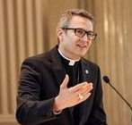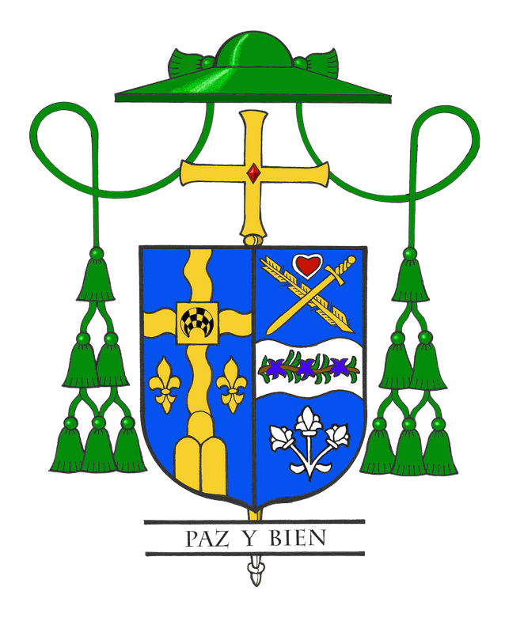Bishop Hicks' Column

June 2022 | National revival celebrates beauty of the Eucharist

Many of you know how excited I am about the three-year National Eucharistic Revival the U.S. Conference of Catholic Bishops will launch on June 19, the Sunday we celebrate the Feast of Corpus Christi or the Solemnity of the Most Holy Body and Blood of Christ. As I was thinking about this important event in the life of our Church, I recalled a boyhood story of a colleague of mine who serves as an auxiliary bishop in another diocese.

When my colleague was elevated to his new post, a journalist with the diocesan newspaper naturally wrote an article about him, talking with family and friends about his background. His mom told a story of how her young son, the new bishop-elect, would set up a makeshift altar on the front porch of the family farmhouse and distribute those thin, wafer mints as the Eucharist. She told the journalist that her son insisted that everyone receive “Communion” and be good Catholics.

I love the innocence of this story, since my colleague knew even as a young boy the value and importance of the Eucharist. My hope for this eucharistic revival is that it echoes the holistic simplicity of my colleague’s boyhood mission. Soulful knowledge of the beauty of the whole of the Eucharist encompasses everything from adoration to praise to consumption to going out into the world to put our faith into action, nourished by the body of Christ.

Here in the Joliet diocese, we will embark on this eucharistic revival by celebrating a special Mass on Sun., June 19, at the Cathedral of St. Raymond Nonnatus in Joliet. Following the Mass, I will lead a procession around the block on which the cathedral stands, carrying the monstrance and stopping to pray at Polish and Hispanic altars placed along the route.
What better witness to our love of the Eucharist than to proclaim it with a joyful walk that all our neighbors in Christ can see! The procession will then return to the cathedral for benediction. The diocese’s office of divine worship sent out bulletin announcements about the cathedral’s Mass to parishes in May.

I realize that June 19 is also Father’s Day, but what a fine way to thank God our Father for the beautiful gift of the Eucharist by joining this celebratory procession. Let’s not forget the word “Eucharist” is derived from the Greek “eucharistia” for “thanksgiving.”

This year’s Feast of Corpus Christi is only the beginning, as the eucharistic revival will culminate in a National Eucharistic Congress in Indianapolis in 2024 and then a year of following a Holy Spirit-driven mission so that we can truly live as the body of Christ. You can read more about the timeline at the following link: https://www.eucharisticrevival.org/

Additionally, leaders at the parish, deanery, diocesan and national levels will be developing special liturgies and events during the next three years as we seek to keep the Eucharist as “the source and summit of Christian life,” as encouraged by Vatican II.

I hope you share my excitement for this eucharistic revival. I look with inspiration to the homily of Pope Francis on last year’s solemnity: “In the Eucharist, we contemplate and worship the God of love. The Lord who breaks no one, yet allows himself to be broken. The Lord who does not demand sacrifices, but sacrifices himself. The Lord who asks nothing but gives everything. In celebrating and experiencing the Eucharist, we too are called to share in this love.”

