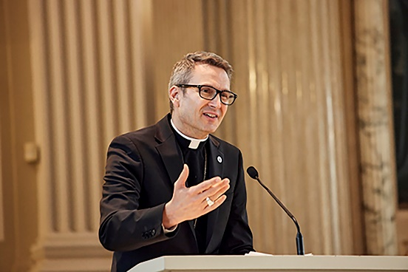RECENTLY, I VISITED A PARISH IN OUR DIOCESE. Immediately after the Mass, I was delighted to begin the “meet and greet” in the narthex. Per usual, the topics of conversation were widely varied. I was struck, however, by a comment made by one of the parishioners. Seemingly out of nowhere, she exhorted me: “Bishop, we are all in need of the month of July!” I think she read the polite—yet confused—look on my face, as she explained, “Life gets so busy and crazy. It seems that July is the only month to slow down, enjoy the warm weather and just chill out!” Nodding with affirmation, I smiled and chuckled as I replied to her, “I think you are right. We all need a little summer in our lives.” With that, a huge smile appeared on her face as she raised her hand to give me an enthusiastic high five.

Truth be told, I love the month of July. I have great childhood memories of mid-summer, specifically about Independence Day. Each year on the Fourth of July, my grandma would host an all-day family gathering at her house in Blue Island, Illinois. My uncles would fire up the large, charcoal grills around 7 a.m. After cooking many pounds of bacon, the eggs then were fried in the drippings. But this annual ritual divided the family down the middle—there were about half of us (including me) who viewed this breakfast as one of the greatest culinary delights of the year. The other half would not permit the grill masters to touch their plates, opting instead for kitchen-made eggs and pancakes with some coffee cake and fruit.

After this grand breakfast, the day would be filled with music, conversation, volleyball, croquet, a beanbag toss, and—for some—a walk to Western Avenue to watch the Fourth of July parade. The day concluded by sitting on lawn chairs and blankets as we watched the fireworks from the local high school as we passed around bug repellant to keep the mosquitoes away.

To this day, I still cherish those family memories of the Fourth of July at my grandma’s. Instead of work, study, or chores, it was a day to truly disconnect from the obligations of life and simply enjoy a full day of food, fun, family, and friends. And like most of us, I relished a break from work and school.

As we enter fully into this month of July, maybe it is not only time to refresh and recharge our lives with some good food, fun, family and friends. Perhaps summertime also is our opportunity to refresh and recharge our spiritual lives.

One way to revive ourselves is to immerse ourselves in God’s creation. In contrast to those gray periods of winter, the sun now shines brightly as our days are longer between sunrise and sunset. The flowers are blooming with vivid colors and the canopy of full trees offer coolness and shade. We can open our windows and listen to birds chirp as we bite into garden-fresh tomatoes, peppers, cherries, and watermelon. It is also a time to notice our neighbors, as many people enjoy a morning or evening walk and children ride bikes around the neighborhood.

How will you refresh and recharge this summer? Perhaps it is the promise of a long-awaited family vacation to a nearby campsite, lake, or amusement park. Or maybe you’ll take a trip to sightsee or visit family and friends afar. During your travels, consider stopping at a shrine or spirituality center along the way.

For others, a “staycation” sounds heavenly. Maybe July will provide you the time to leisurely read a recommended book, clean out the garage, play a board or card game, walk the dog a little longer, or leisurely lay in a hammock or favorite lawn chair and just stare up at the trees or the stars.

On the spiritual level, if you find yourself traveling away from home this summer, please do not take a vacation from attending Mass. Instead of looking at it as a way to merely fulfill an obligation, remember that you’re participating in and receiving the greatest gift that God has given to us—Jesus Christ in the Holy Eucharist. Attending a different Catholic church also can invigorate us while we experience new congregations, listen to different homilists, and worship with other choirs and musicians.

As Catholics, we are reminded that while we embrace the downtime of summer, there is no need to take a break from God! In fact, it’s a wonderful time to invite Jesus Christ into your summer experience. For like I was told in the narthex after Mass, we need the month of July! This is the perfect month to refresh and recharge our spiritual lives.

May you have a happy summer and may God bless and protect you always.

